**Summer Task_SatabdaChaudhuri_Electrical_19BEE1024_TCR**

**Model NO:-** ***STM32F401RET6 (ARM Cortex M4 32-bit)***

**Specifications:-** It comes with an integrated platform of ST-LINK/V2-1 programmer and debugger.

**Overall Specs:-**

1. There are three pins at all out of them –

LD1- For the purpose of indicating USB communication

LD-2 – It is a user programmable led(which means user can programme it)

LD-3-It is used for the purpose of Power Indication

1. There are two switches in the board –

B1 USER Button- It is an user programmable button.

B2 Reset Button- It is used as the reset switch of the microcontroller or to reset the Microcontroller.

1. The board operates with a voltage of 3.3 V supply .
2. For the Vin pin we can provide the voltage of the range of 7-12V because it has an onboard voltage regulator
3. In this board there are two sets of pins which can be classified in different types;

* Arduino UNO:- The part consisting the style like the Arduino Model Pin Configuration .These are female connector pins having the same order and configuration of Arduino UNO. So, the user can use any Arduino Shield for this type boards.
* STM Type:- The Blue part of the board(STM 32 Style). The name of this type board is “Morpho”7.
* Detailed Description About the board Pins and their Functions Individually:-

1. The Part of STM-32 of Arduino UNO style:-

|  |  |
| --- | --- |
| **Type of Pin or Name** | **Description with working Significance** |
| IOREF | Input and Output Reference Pin for Power Supply 3.3 V |
| CN6 | Power |
| RESET | Resets the Microcontroller |
| Type of Pin or Name | Description with Working Significance |
| +3.3V | This delivers an output of 3.3 V which can be used for the MCU |
| +5V | For the output of 5V only |
| GND | Ground pins to ground the connection |
| CN8 | Analog Type Pins |
| A0-A1 | Pins used to measure the analog pin signals |
| A4-A5 | User an use this pins for the 12C communication . Here A4 is SDA(Serial Data) and A5 is the SCL(Clock Line , to synchronize all data transfers over the 12C Bus. |
| CN5 | Digital Pins and SPI(Serial Peripheral Interface, used to sent data to Microcontrollers and small peripherals) |
| D8-D15 | Digital GPIO Pins(General Purpose Input/Output Pins used by the user for the different purposes of input or output as per the user) |
| AVDD | Can be used for the analog reference voltage |
| GND | Ground Pins for the grounding of the connections |
| D13,D12,D11,D10 | Performs the task of SCK(The Clock pulses which synchronize data transmission generated by the master),MISO(Master Input Slave Output),MOSI(Master Output Slave Input, which is a data line to connect the master and slave for the connection purpose ),CS(Chip Select, A Control Line to select definite I.Cs.) respectively for SPI Communication. |
| CN9 | For the purpose of denoting Digital Pins and USART. |
| D0-D7 | These are for the Digital GPIO pins(General Purpose of Input/Output) |
| D0 and D1 | Acts as RX and TX pins for USART Communication. |
|  |  |

1. The Part of STM of “Morpho” Style:-

After Arduino UNO the board has 76 GPIO pins at both side of the board where those are distributed as 38+38 aside .These pins are classified as into CN7 and CN10 with each having 38 pins .They have GPIO pins, Analog ,Timer and Power Pins which are classified as per the table as below;

|  |  |  |  |
| --- | --- | --- | --- |
| **Pin Category** | **Pin Type** | **Pin Names** | **Description** |
| CN7 | Port Pins | PC0,PC1,PC2,  PC3,PC10,PC11,  PC12,PC13,PC14  PC15 | Port C digital Input /Output Pins. |
| PD2 | Port D input/Output Pins |  |  |
| PA0,PA1,PA4,  PA13,PA14,PA15 | Port A Input/Output Pins |  |  |
| PB7,PB8 and PB9 | Port B Input/Output Pins |  |  |
| PH0,PH1 | Port H Input/Output Pins |  |  |
| VBAT | Power |  | Can be used to power the module by using the battery |
| Pin Category | Pin Type | Pin Names | Description |
| +3.3V | Delivers 3.3V as an ouput can be used also to power the MCU(Microcontroller Unit) |  |  |
| +5V | Pin for a 5V output |  |  |
| Vin | Unregulated input Power Pin |  |  |
| RESET | RESETs the MCU system |  |  |
| IOREF | Input and Output Reference Voltage Pin |  |  |
| CN10 | Port Pins | PC4,PC5,PC6,PC7,PC8,PC9 | Port C Input or Output Pins |
| PA2,PA3,PA4,PA6,PA7  ,PA10,PA11 and PA12 | Port A Input/Output Pins |  |  |
| PB1,PB2,PB3,PB4,PB5,  PB6,PB8,PB9,PB10,  PB12,PB14,PB15 | Port B Input/Output Pins |  |  |
| Power | U5V | 5V Power Pin | To Deliver a voltage of 5V |
| GND | System Ground of the MCU |  |  |
| AGND | Analog Ground Pin |  |  |

Sources of Data:- [https://components101.com/microcontrollers/stm32-nucleo-f401re-pinout-datasheethttps://components101.com/microcontrollers/stm32-nucleo-f401re-pinout-datasheet](https://components101.com/microcontrollers/stm32-nucleo-f401re-pinout-datasheet)

**Technical Specifications[Based on Power Rating ,Current and Voltage Consumption Rate]:-**

1. Power Consumption: 2.4 uA standby without RTC(Real Time Clock)
2. CPU Frequency:84MHz
3. Crystal Oscillator Range:4-26MHz
4. MCU Operating Voltage (VDD):1.7V-3.6V
5. Board Operating Voltage(Vin):7V-15V
6. Flash Memory:512KB
7. SRAM:96KB

The Connection of a Servo Motor with two Ultrasonic Sensors:-

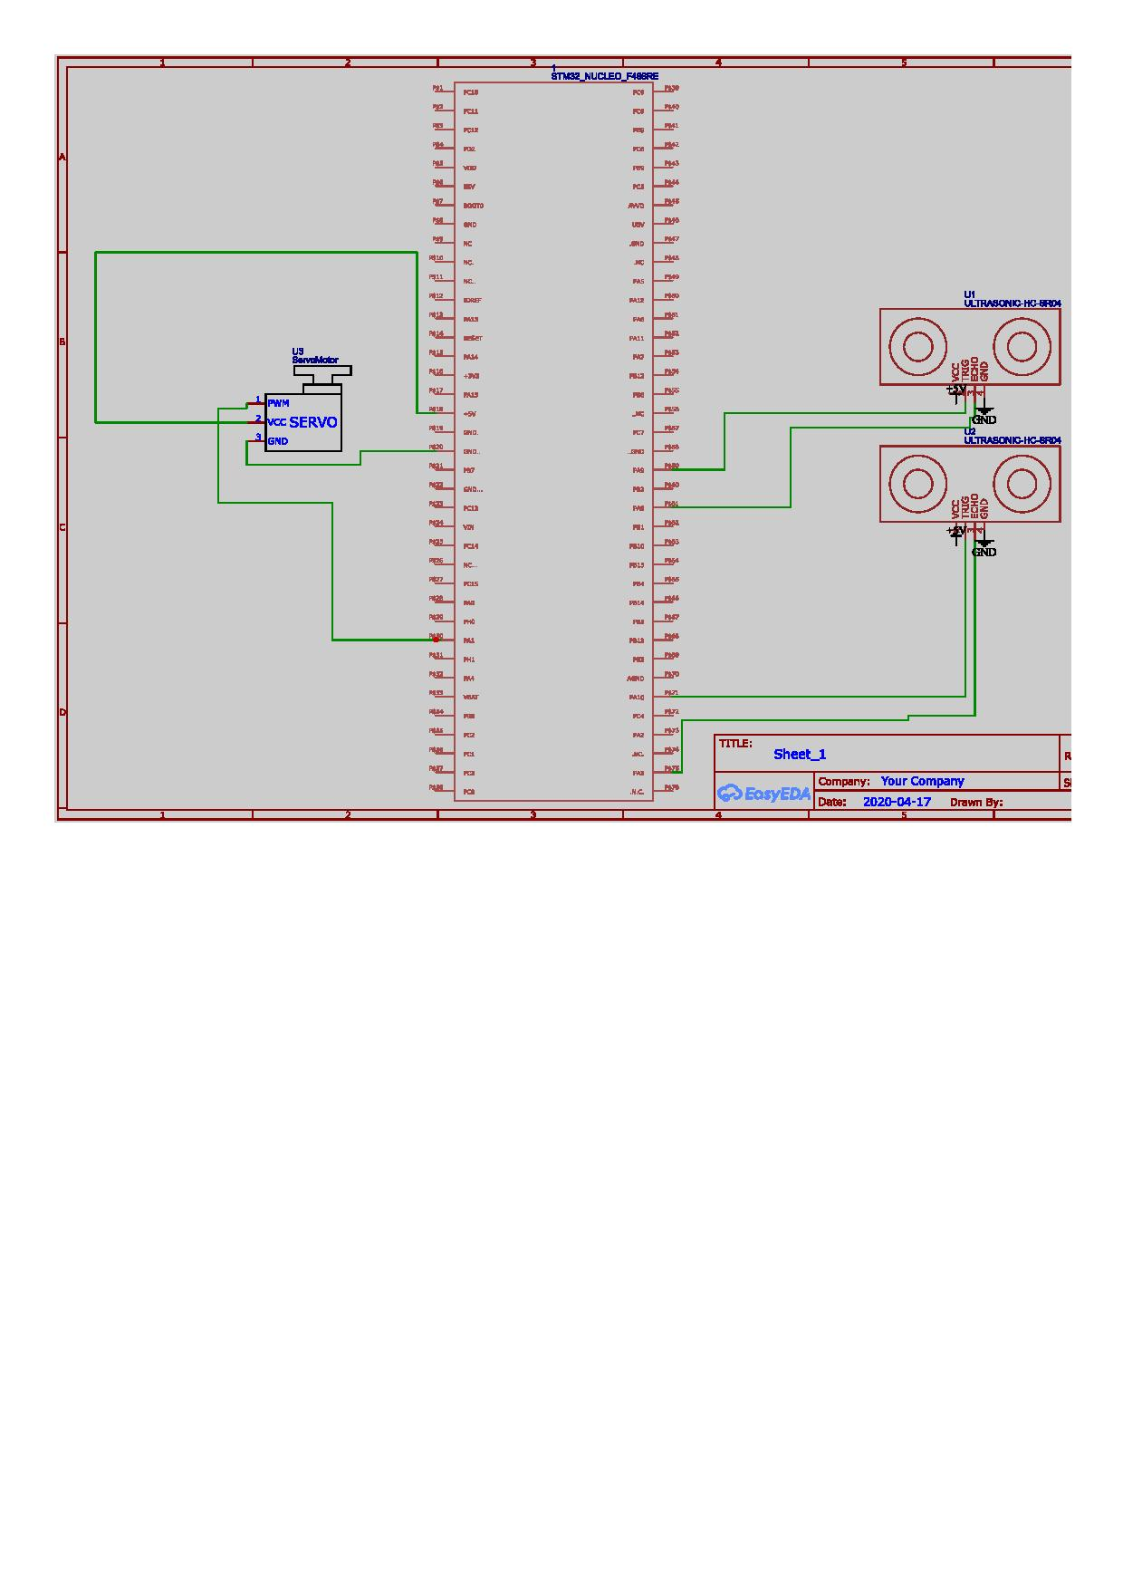

b) **The Difference Between the STM Nucleo and Arduino;**

1. The classification of them is strictly based on the task and their complexity of processing.

2. Arduino is specifically a platform which runs in some definite IDE platforms where the provided library is enough to process a task .So, where the task is easy or the complexity is minimum or less ,then we can use it as a microcontroller .

But if in any task we need more perfection and compactness then we have to use the STM .Because; the compactness of it’s library is more better then that of Arduino to handle various complicated problems .Moreover works with different types of IDE in some of them they are compatible with Arduino also to work as an IDE but in majorities the environment is much more complex and compact than the Arduino .So, for such problems and works we have to switch within STM and Arduino.

3. Arduino is a complete microproccessing board where the STM is a set of Microcontrollers.

**Coding Task:-**

**b)**

#include <Servo.h>

Servo servo1; Servo servo2;

int i = 0;

int a = 180-i;

void setup() {

servo1.attach(3);//servo1 is attached with the pwm pin 3:

servo2.attach(5);//servo2 is attached with the pwm pin 5:

}

void loop() {

for(i = 0;i > 0;i++){ servo1.write(i); delay(10);

}

for(a = 0;a < 180;a--){ servo2.write(a); delay(10);

}

}

**Automation Task:-** One of the important tasks in the field of agriculture is the parameters of humidity , temperature and Ph . Because based on those parameters we have to the survey about the productivity parameters of the soil which signifies the types of harvesting can be done and which time will be the best for that case to use that land for agriculture and the rate of usage(How many times in a year it can be used) and according to that survey data if we want to increase the quality and the rate of usage what we have to do based on the treatment sections of a land to make it more fertile (which leads to the usage of fertilizers and insecticides) can be described a s a bulletin or general instruction for the farmers or the persons who are involved in this field.

So, our aim is to automate the whole system according wise to automate which will be enable to give the data surveys by using a bot where the individual sensors will be to provide the necessary data points with the necessary parameters .So ,we will use this components to collect those data which are;

1)**Ph Values:-** Ph is a chemical parameter to analyze the type of the soil .It is a expression of negative logarithmic concentrations. According to the values of that function we have to take decisions about the type of that soil .There is a scale named as PH Scale which is a parameter through which we will know about the soil type by comparing the standard values and that of the results of us. If the value of Ph is less than 7 then it’s acidic and if greater than 7 is basic.

So, to analyze that we will use the ***Ph sensor*** connected with Arduino UNO.

2)**Humidity and Temperature Values:-** To collect the data about the temperature and the humidity and the other parameters of that area at various seasons to decide which season is best for cultivation and usage of that land of that area .

So, we are using a ***Humidity and Temperature Sensor*** connected with the same Arduino UNO .

3)**Motional Parts Required :-** to facilitate the motion of the bot we need one ***Ultrasonic Sensor*** and three general high torque motors .If there is any obstacle then it will identify and go through an alternative path.

The connections of the whole system will be;

